Sequence Retriever

Use Case Model
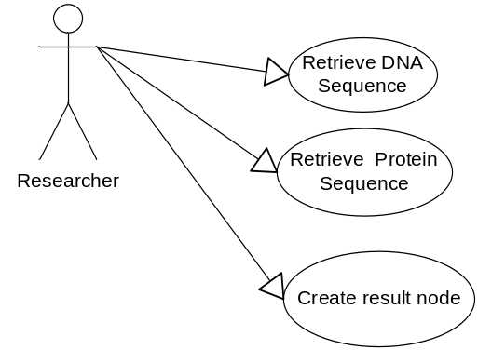

Brief Description
The Sequence Retriever is located in the top-right of the application. This component retrieves sequences from local and remote sources. The sequences retrieved can be selected and added to project as a dataset data node which can be viewed in the Promoter Panel, Sequence Panel and Position Histogram.

Sequence data
This use case describes accessing DNA sequence and Protein Sequences. The user can select where to obtain the sequence data. The table below describes the available data sources.
Sequence Data Type | Source Description
Protein | EMBL  URL:  Description:
Protein | caBIO  URL:  Description:
DNA | UC Santa Cruz  URL:  Description:
DNA | caBIO  URL:  Description:
DNA | Local Cache  Url:  Description:

DNA results description
For each retrieved DNA sequence, the corresponding marker's name will be displayed to the left of the retrieved sequence. Where possible, data will be collected from the sequence data source about the retrieved sequences, including: Organism, Chromosome, Chromosome location. Such data will be displayed next to the sequence header within the pane that appears when double-clicking on a sequence. Each field is separated by '|'. Each field is explained below:
Name of the maker_Organism|chomosomne|chromosome number

For example:
marker_Q3B891 |Homo sapiens|
BRCA1|Q3B891_HUMAN|Hypothetical protein

Protein results description
For each retrieved protein sequence the protein sequence name shall be displayed to the left on the sequence. When the source supports, protein names will be hyperlinked to URLs providing sequence annotation.

Note: Development team please document a description from marker selection to protein for each data source. The Sequences are retrieved based on their universal identifiers.

Views
The sequence panel includes a line view and a full character string sequence view. In both views the user can view the numeric position reference in a tool tip. A single click on a line or sequence string results in the Sequence Detail pane at the bottom of the UI populating with the character strings of sequence string selected. The display of sequence details is proportional to the click position. The pane includes numeric position reference and supports shifting to the left and right of the selection. Double clicking in the line view updates the sequence display pane to include the full character string for the selected sequence. When a user changes the type selector ("DNA", "Protein"), the system shall redraw the sequence display to reflect the most recent selections for this type.

Child Data Node
Each retrieved sequence shall have a selection check box (similar to the ones in the panel displaying BLAST results) which allows users to select which sequences will be added to the project when the "Add to project" button is selected. A "select/unselect all" option allows users to select or unselect the selection boxes for all retrieved sequences.
If the user opts to add the retrieved sequences to the project panel, the system shall capture in a log entry (within the dataset history panel) the input markers parameters used for the retrieval.

Marker Selection
The marker selection pane includes a marker (default) and find marker tab. When the data source and type is selected, the Marker tab is populated with markers from the selected data source. After the user clicks Get Sequence, the system indicates visually that sequences have been retrieved for the select markers. Total number sequences is included in the Sequence Display.. This value is refreshed when the view is updated.
In the Find Makers, the user can retrieve sequence by finding and selecting a specific marker(s) from the data source and displaying only sequence that corresponds to the selected marker(s).

Primary Actor

Researcher

Preconditions
- User has accessed the workbench.

Basic Flow of Events
Actor Action | System Response
- User selects the Sequence Retrieval visualization. | - Display: System display Sequence Retriever.
- User selected the type of sequences from the ‘Type’ drop down list. | - System updates the display to reflect the selection of the sequence type.  Note: Data Source dropdown list is updated to limited to sources for that data type
- User selects a ‘Data Source’ from the list of available data sources. | - System updates the display to reflect the selection of the data source.  - Local: The markers included in the activated marker panel are displayed in the Selected Markers section of the user interface.  - Remote: Markers from the selected file are displayed in the Selected Markers section of the user interface.
- User clicks ‘Get Sequence’. | - Results: System displays an indicator that the retrieval is in progress in the Sequence Retriever User Interface.  - System attempts to retrieve the sequence data from the data source specified.
- To stop the retrieval process, see subflow – Stop. | - System displays the results. System highlights the markers to indicate that sequences have been retrieved for the select marker.  - The system updates the value of the total number sequences displayed in the view. If no results found, see error flow.
- User single clicks on sequence line or character string, see subflow - Sequence Details.  - In the line view, the user double clicks on sequence line or character string, see subflow - Sequence Toggle.  - To change to Full Sequence display format, see subflow – Full Sequence.  - To change to type selector, see subflow – Change Type.  - To select a specific marker(s) and displaying only sequence that corresponds to the selected marker(s) flow – Select Marker.  - To clear results – user click on the Clear button, system removes results from the Sequence Display and returns to Display step.  - To modify the values of the upstream/ downstream, see subflow – Modify Sequence Range.  - To modify which sequences will be added the project, see subflow – Add to Project.  - To view protein sequence description- see subflow – Protein Details. | - End

Subflow – Change Type
Actor Action | System Response
- System redraws the sequence display to reflect the most recent selections for this sequence type.
Note: Users will need to select ‘Get sequence’ to obtain result for the new type.

Subflow – Find Marker
Actor Action | System Response
- In the Marker Selection pane, the user selects the Find Marker tab. | - System displays the Find Marker pane.
- Enter Gene: User enters a Marker in the ‘Enter Marker text box’. | - System searches the data source for the marker specified.  - If found, the system will display the gene in the text box below the search field. If no results found, see error flow.
- User can repeat Enter Gene Step or  - User clicks on a marker in the Find Marker pane, right clicks, selects Remove. System removes the marker from the display.  - User clicks ‘Get Sequence’. | - Return to main flow – Results step.

Subflow – Select Marker
Actor Action | System Response
- User clicks on a marker from the Marker selection pane. | - The system will display only the sequence that corresponds to the selected marker(s).
- User right clicks, selects Reset. | - System displays the all of the sequences retrieved.  - Return to main flow – Results step.

Subflow – Stop
Actor Action | System Response
- User clicks on ‘Stop’. | - System discontinues retrieval efforts.  - Return to main flow – Display step.

Subflow – Modify Sequence Range
Actor Action | System Response
- If needed, the user modifies the upstream value by entering a numeric value in the + text box or click the up/down arrows.  - If needed, the user modifies the downstream value by entering a numeric value in the - text box or click the up/down arrows. | - System updates the display of the Sequence Range.
- User clicks on ‘Get Sequence’ | - System redraws the sequence display to reflect the most recent selections for this type.  - Return to main flow – Results step.

Subflow – Add to project
Actor Action | System Response
- Select: User unselects sequences to not include in the results. | - System updates the display to reflect the selected sequences.
- User repeat Select step or,  - If satisfied, user clicks ‘Add to Project’. | - System adds to the Project pane a child node sequence dataset of the displayed data. If no items are selected, Error flow.
- System captures in a log entry (within the dataset history panel) the input markers parameters used for the retrieval.
Return to main flow – Results step.

Subflow – Sequence Details
Actor Action | System Response
- System updates the Sequence Details text box to include the sequence string at the bottom of the view with the matching location centered in the view.
Note: Every 40 characters, this sequence detail shall include the numeric position.
- User can view to right of the sequence string displayed in the window by clicking on the right arrow | - System updates the Sequence Details display to view the 40 characters to the right (if possible).
- User can view to left of the sequence string displayed in the window by clicking on the left arrow | - System updates the Sequence Details display to view the 40 characters to the left (if possible).  - Return to main flow – Results step.

Subflow – Sequence Toggle
Actor Action | System Response
 | - System updates display to reflect the full character string of the sequence line selected.
- The user double clicks on the character string to return to the line view. | - Return to main flow – Results step.

Subflow – Full Sequence
Actor Action | System Response
- User selects from the type dropdown list Full Sequence. | - System updates the display to include character strings for each sequence.  - Return to main flow – Results step.

Subflow – Protein Details
Actor Action | System Response
- User clicks on the Protein Sequence Name hyperlink.  Note: If addition data is available, the Protein Name is a hyperlink. | - System displays another window with to URLs providing sequence annotation.  - Return to main flow – Results step.

Error Flow – No Records
Actor Action | System Response
- System displays a descriptive error message.
- Return to main flow – Results step.

Postconditions

None

User Interface

Sequence Retriever – UI Description

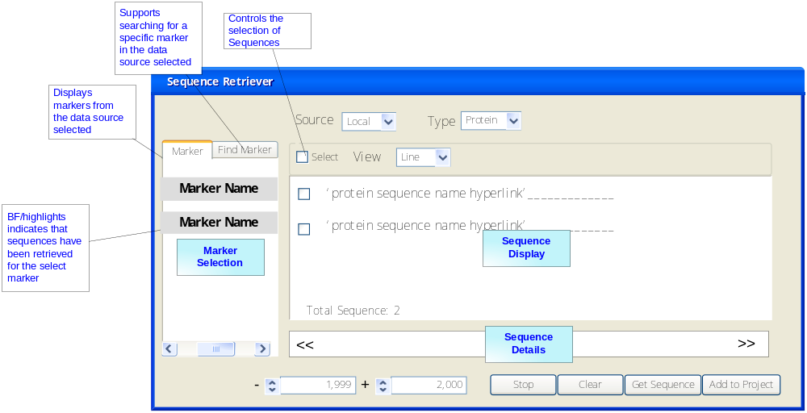

Sequence Retriever – DNA Line View
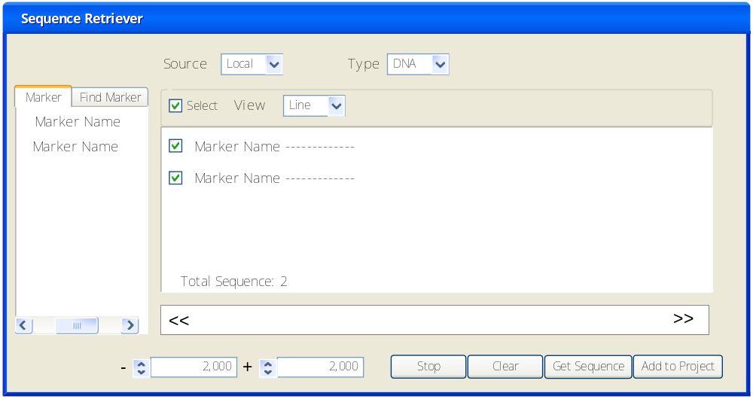

Sequence Retriever – Find Marker
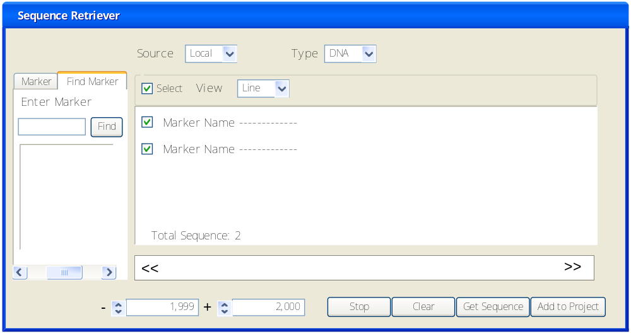

Sequence Retriever – DNA Line Full Sequence
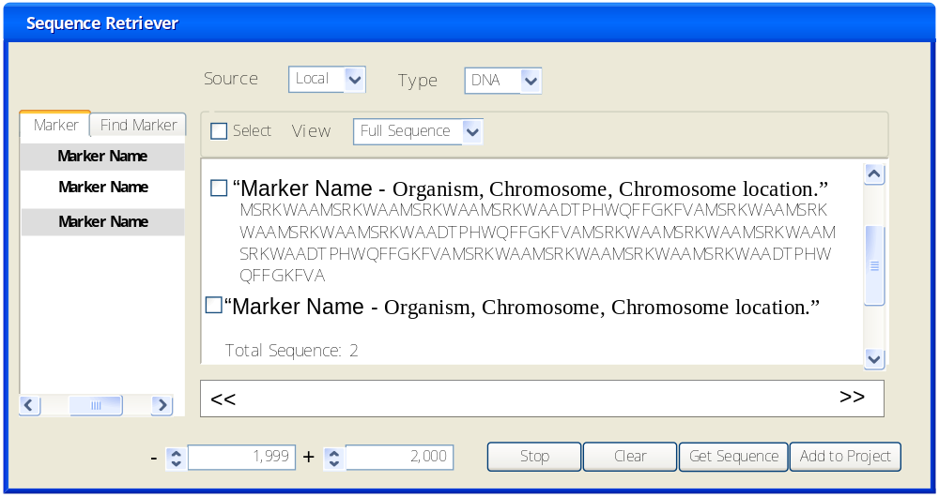

Sequence Retriever - Protein
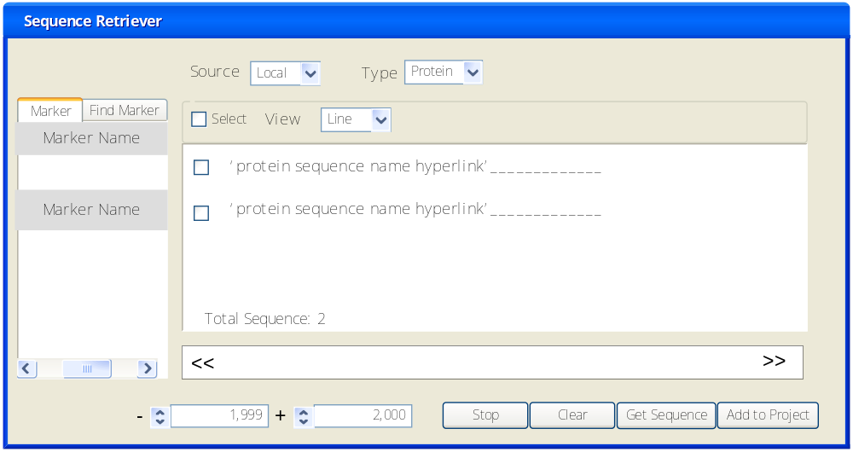

Field Name | Type | Description
Source | Drop down | Default – Local. Drop-down list indicating the data source where data are obtained from. Option may be "Local cache", "caBIO", "EMBL", etc..
Find Marker tab | Tab | Displays the Find Marker pane that supports searching a dataset for marker(s) entered in the search field.
Marker tab | Tab | Default - Displays the markers in the selected data source.
Type | Drop down  ( DNA or Protein) | Default – DNA  Specifies the type of sequence data to be retrieved.
View | Drop down  Line or Full Sequence | Default – Line.  Line: Each sequence is represented by a line proportional to its length, preceded by the sequence ID. A user can mouse over a string and the numeric position is displayed (as in the promoter) on a line.  Full Sequence: The full character strings for the sequences are displayed preceded by the sequence ID.
Shift left/ Shift Right | Arrow | The Sequence Details will include Shift left/ Shift Right arrows if the sequence to allow for scrolling to view the sequence.
select/unselect all | Checkbox | A "select/unselect all" option allows users to select or unselect the selection boxes for all retrieved sequences
Clear | Button | Remove results from the Sequence Display.
Upstream/downstream regions | Textbox | 2000 - default  ‘-‘ text box captures the downstream region.  ‘+” text box captures the upstream region.
Stop | Button | Stopping an ongoing retrieval attempt.
Sequence Detail | Text Area | A user can single click on a line or sequence string, the Sequence Detail will populate with the character strings of the section of the sequence string selected. The display of sequence details is proportional to the click position in the line.  In the line view, double clicking displays the selected full character string. The user double clicks on the character string to return to the line view.  In both displays, the sequence detail shall include the numeric position of every 40 characters.
Numeric Position Reference | Text | The Sequence Details include a numeric position reference every 40 characters.
Total Sequence | Display | Total number sequences displayed in the view. This value is refreshed when the view is updated.

